Q1. What should be the output? ( 3 + 4 ** 6 - 9 * 10 / 2 )

Ans

Output will be : 4054.0

Q2. Let say I have, some string "hello this side regex"

Find out the count of the total vowels.

vowels - ['a','e','i','o','u']

Ans.

string ="hello this side regex"

vowel_counts = {}

for vowel in "aeiou":

count = string.count(vowel)

vowel_counts[vowel] = count

print(vowel_counts)

Output will be:

{'a': 0, 'e': 4, 'i': 2, 'o': 1, 'u': 0}

Q3. Find out the area of triangle.

1/2 * b * h (formula of area)

- You have to take value from user about the base, & the height.

Ans

base=int(input("Enter the base of the triangle"))

height=int(input("Enter the height of the triangle"))

area=base*height/2

print(area)

Q4. Print the calendar on the terminal. If you give the year.

- Allow the user to input the year.

- Then print calendar of that year.

Ans.

Import os

Year=int(input(“Enter the year”))

os.system(“cal {}”.format(year))

Tried the above code in RedHat Terminal and it gave the required output.

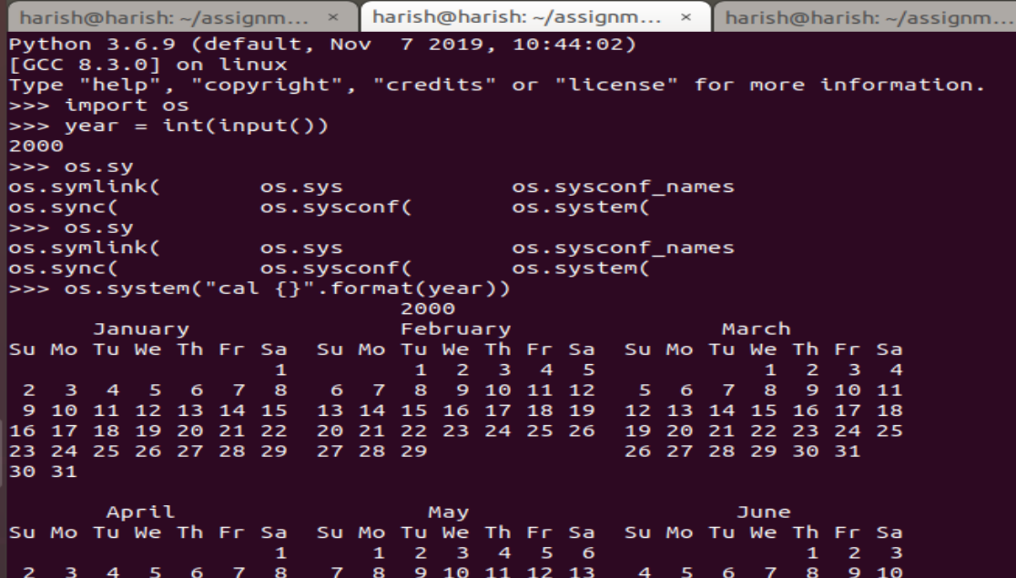

Submitted by

Harish Kumar Jangir